PIZZA SALES SQL QUERIES

A KPI’S

1. Total Revenue



1. Average Order Value



1. Total pizzas sold

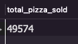

1. Total orders



1. Average Pizzas per order



1. Daily trend for total orders

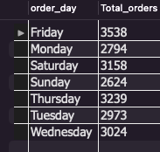

1. Hourly Trend for Total orders

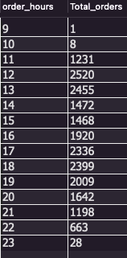

1. Percentage of Sales by Pizza Category

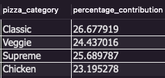

1. Percentage of sales by Pizza Size

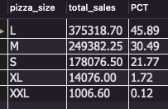

1. Total Pizzas Sold by Pizza Category

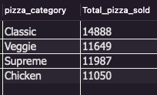

1. Top 5 Sellers by total Pizza sold

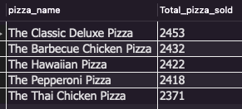

1. Bottom 5 Sellers by total pizza sold

